**Instrumentation setup**

***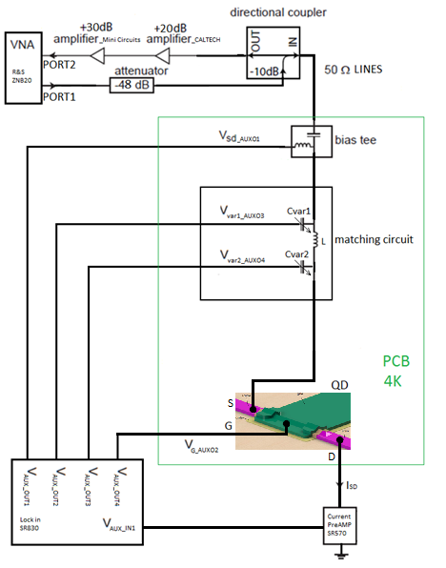***

Figure 6: Simplified schematic of the overall measurement circuit

For conducting the measurements several instruments have been used.

* Reflection coefficient measurement: vector network analyzer (VNA) from Rohde and Schwarz, model ZNB20
* DC biasing of the single hole transistor: auxiliary bias outputs of a Stanford Research SR830 lock-in amplifier
* DC current measurements: current amplifier from Stanford Research SR570
* For attenuating the RF signal sent to the sample: Minicircuit’s attenuator
* For amplifying the reflected from the sample RF signal: series of Minicircuit’s and CITLF3 low noise amplifier
* Instrument control and data retrieval to the PC: Python application.

#### Germanium nanowire based, hole spin single quantum dot tuning and characterization with the initial version reflectometry setup

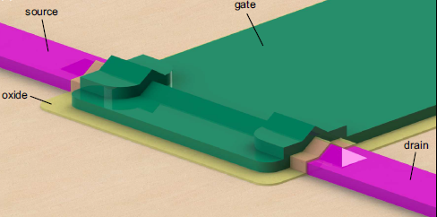

Figure 7: 3D model of a silicon germanium nanowire-based single quantum dot sample SHT, designed by H. Watzinger. A single quantum dot which confines holes is formed in the nanowire beneath the gate (green).

The single hole transistor sample was fabricated by H. Watzinger and the nanofabrication description can be found in [10].

Using the setup described in previous chapter, the SHT formed as a single quantum dot in the germanium nanowire (Figure 7) was tuned in the Coulomb blockade regime applying DC voltages on source, drain and gate electrodes (Figure 6). Charge stability measurements were conducted in the Coulomb blockade regime a showing Coulomb diamond pattern, as in [10]. A Comparison of the DC current and ohmic reflectometry measurements has been done. The DC current was measured by applying a bias on source and reading the current from drain contact (Figure 6), while for the reflectometry measurement the LC matching circuit was connected to the SHT source contact (Figure 6).

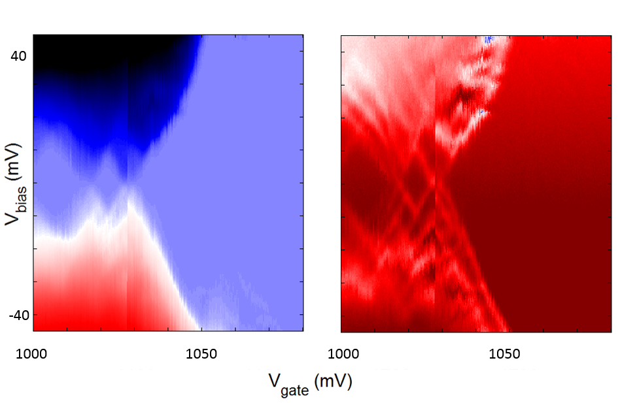

Figure 8: Comparison of the DC current transport (left) and the ohmic reflectometry (right) measurements of the SHT charge stability measurement.

By adjusting the integration time to be similar for both measurements, it can be seen that the reflectometry technique enables us to see more features like the excited orbital energy states of the SHT (Figure 8).

We have compared our reflectometry setup with the result of D. J. Reilly, C. M. Marcus et al [19] where they reported conductance sensitivity of 5\*10-6 e2/h Hz−1/2 by performing reflectometry on the quantum point contact in dilution fridge with electron temperature of 120 mK. Following the same principle of sensitivity measurement as in [19] we have gotten around five times lower sensitivity, but our measurement is performed on the 4 K temperature and Coulomb peaks of our SHT are much broader which reduces sensitivity.

#### Second generation of the reflectometry setup

The initial measurements have been done in a liquid helium dewar at 4 K temperature. Going lower in temperature, further decreases the electron temperature needed to resolve the physical effects in the next experiments. Maybe here you can write that for lower temperature you expect sharper coulomb peaks, thus higher sensitivity. I think what is missing in the previous section is to speak what is the sensitivity of your setup. I kind of remember you had done this in Linz right?

The first generation of the used setup and pcb board aimed to verify that indeed we have the knowhow to perform RF reflectometry measurements. The second generation of the reflectometry setup will be installed in dilution fridges allowing us to achieve temperatures down to 10 mK.

For the purpose of measuring several samples and due to the necessity for a higher number of RF lines dictated by experiments of spin manipulation, a new PCB will be designed (do not show it). The new design will allow frequency multiplexing of four different reflectometry resonant circuits enabling the measurement of four samples by using just one RF line (at once, is this true? With the UHF we can measure two in parallel but not all the 4 or am I wrong?). We will install in the dilution fridge insert a similar reflectometry system like the one used in the 4K dip-stick. However there will be several improvements. There will be an upgrade in terms of using lower thermal conducting stainless steel and superconducting niobium titanium coaxial cables, attenuators, and additional DC filtering of all the DC wires. In addition, a Niobium titanium superconducting cable is going to be used between the input of the cryogenic amplifier and sample stage because of its very low thermal conduction, to avoid heating of the mixing chamber stage of the fridge which has cooling power of a few tens of uW in the insert.

#### K:\mess\Josip_PCB_photos\WP_20160601_15_55_41_Pro.jpg

Figure 9: Newer version of the PCB (green) with the mounted sample (middle, grey) fabricated in our group by Lada Vukušić. Altogether mounted on the golden plated copper fork on the dilution fridge insert. The copper colored wires are the coaxial cables providing the high frequency connection for a spin manipulation and readout. ( I would delete this picture)

*Maybe I can put some nicer picture of PCB + PCB holder, we have some pretty, artistic like ones.  
Maybe put the some picture of the probe (currently I don’t have the nice one)*

The vector network analyzer which was used so far for the measurements will be replaced with a Zurich Instruments UHF lock in amplifier which enables faster and longer data acquisition, more inputs and generally more measurement flexibility. (For the spin relaxation time and spin manipulation measurement arbitrary waveform microsecond pulses with a nanosecond rise time are needed. Those are generated using a Tektronix AWG5014C. Measurement is conducted using the QTLab measurement application developed in Python initially by Delft Quantum Transport (QT) laboratory. We modified it according to our need. All the codes can be found on the GitHub. This part should go below when you describe the experiments)

#### Moving to the gate reflectometry

As in the ohmic reflectrometry also for the gate reflectometry the readout parameters are the phase shift ∆φ and the amplitude change ∆γ of the reflected signal due to the charge configuration change in the quantum dot or double quantum dot system. , , , where Q is the quality factor of the resonant circuit, Cp is parasitic capacitance, Cg is gate to dot coupling capacitance and CΣ is quantum dot overall capacitance [12]. Is there an intuitive argument why it scales with the the square of alpha? From the above expressions it can be seen that higher dot to gate coupling Cg leads to higher sensitivity of both ∆φ and ∆γ. Since the gate electrode and the nanowire separated by a thin dielectric form approximately a parallel plate capacitor structure (since… what is happening?). Using gate reflectometry in gate defined DQD in GaAs J.I. Colless et al. achieved charge sensitivity of 6.3 meHz-1/2, having Cg/CΣ ≈ 0.05 [14]. Using 1.9 nm HfSiON oxide as dielectric in a silicon nanowire field effect transistor, M.F. Gonzalez – Zalba et al. achieved the charge sensitivity of 37 μeHz-1/2, with Cg/CΣ = 0.92 [12] (compary it with ohmic reflectometry). In our system using HfO2 as a dielectric, which has εroxide = 24, we can have a film of 4nm in thickness, so we expect to have a Cg/CΣ comparable to that reported in [12].

*(Here it is maybe possible to put in Qucs simulation using circuit model similar to Natalia but adopted for gate reflectometry, to see how the quality factor of reflection parameter is changing with L and C.Nice Idea)*

From the equation for ∆φ, it seems that the strategy for getting a sensitive gate reflectometry setup involves two things. Firstly to reduce the parasitic capacitance as much as possible by engineering the sample holder, as described in the “Readout circuit” chapter(It is not described there anymore). Secondly, to tune the reflectometry to the good matching condition by changing the inductor values in the resonant circuit (should we speak about the quality factor of the dip?).

**The first generation of the gate reflectometry setup will emerge from the second generation of the ohmic reflectometry** by **changing inductor values** and by trying inductors of different core material and size in order to reduce inductor losses.

#### Optimizing the gate reflectometry:

There are several sources for signal loss in a gate reflectometry system: inductor losses, PCB dielectric losses, losses in PCB RF transmission lines, losses caused by the geometric parasitic capacitance [12]. (you should follow bellow the same order)

For **minimization of the geometric parasitic capacitance** coming from the coupling of the PCB RF lines and bonding pads to the ground planes, Sonnet software can be used. *(Maybe to put here – optimization based on Sonnet – Matlab (Octave) communication) (what we should write is what exactly is sonnet going to simulate, what quantity)*

The RF lines transmission losses come probably from the unwanted reflections due to the transmission line routing and splitting needed to connect more reflectometry readout circuits – frequency multiplexing. This assumption should be tested and the **optimum configuration of the PCB RF lines** could be achieved by using the Sonnet software for simulating the RF line scattering parameters.

The inductor losses come from the dissipation on the ohmic resistance of the wire wound and core losses due to hysteresis (of what?) and eddy currents (the second part of the sentence is not so clear to me). The overall loss can be represented by adding next to the inductor a series resistance (is this what you want to say?) Inductors with air core have smaller core losses but for achieving high inductor values they need to have more wounds and they are bigger, lowering their self – resonant frequency and increasing wire resistance. As a part of this work, **examination of the inductor influence** on the gate reflectometry sensitivity regarding the core material and the inductance value will be conducted.

Losses in the PCB dielectric will be addressed by using dielectric with lower dielectric loss then currently used FR4, e.g. some of the Rogers Corporation laminates.

#### Measuring the spin relaxation time T1

Start with a smooth transition like: once the gate reflectometry setup will be properly working I will focus on performing spin manipulation experiments. During my PhD I will focus on the LD spin qubit in a double dot device.

*(Explained for the spin ½ double dot qubit- this you need to explain; see above my comment about making a transition) (many of the stuff in this explanation are copied from your Marie Curie proposal- no problem ! ☺)*

For measuring the spin relaxation time a three level pulse sequence will be used, similar to approach of Morello et al. [4] (I guess it is the Elzerman paper which we should cite] but for a double QD (DQD) configuration. The DQD will be tuned to a the (0,1)-(1,1)-(0,2) triple point The left dot is initially empty while the right dot is populated with a spin up hole. First, pulsing the gate of the left dot brings its spin up and spin down energy levels below the Fermi level, μF, of the lead. *(I am not sure here, weather for the holes Fermi energy need to be above or lower to allow tunneling- everything is inverted, holes go to higher energy levels)* Since the tunneling is most likely spin independent, the left dot is loaded with a random hole spin from the lead, during the loading time tL. The double dot is left in that configuration for the waiting time tw. After the tw, the second pulse level brings the higher energy spin down level (for Ge the higher energy state has spin up) of the left dot in the resonance with the empty spin down level of the right dot (singlet state). If the spin down electron have been loaded to the left dot during the tL, it will tunnel to the right dot in the read phase, causing the shift in the quantum capacitance (you have not defined it) which is read by the gate reflectometry. Otherwise it will stay on the left dot, causing a zero gate reflectometry readout. The probability of finding the electron in the excited spin-down state will decay exponentially with the duration of the waiting time tw, with *T*1 being the decay constant.

#### Spin manipulation measurements

Quantum gate operations for a spin qubit system implies spin manipulation. Basically such manipulations are spin rotations in the spin representation sphere, called Bloch sphere.



Figure 10. Bloch sphere

The spin-up and spin-down states form the basis of the hole spin qubit and they are located on the north and south pole of the Bloch sphere. Their energy splitting EZ is determined by the hole g factor g, the Bohr magneton μB and a static external magnetic field B, as . The spin vector precesses around the applied static magnetic field (basis states axes) with a so called Larmor frequency , where h is the Planck constant. For flipping the spin an external oscillatory magnetic field BAC needs to be applied perpendicular to the static one and its frequency needs to match the Larmor frequency. An intuitive understanding why the frequency of the Bac needs to match the Larmor frequency can be obtained by thinking of the example of a child on a swing. The child-swing system oscillates with its natural frequency of oscillation. If the swing is pushed by an external person with an appropriate period of pushing pulses, the amplitude of the oscillation will increase and at some point the swing will flip. In this comparison the natural frequency of a child-swing system corresponds to the Larmor frequency and the frequency of externally applied pushing pulses to the frequency of the applied oscillatory magnetic field.

However, an oscillatory magnetic field is hard to implement, from the fabrication standpoint, since it adds more steps and thus the risk of failure One way to avoid this problem is to apply static a instead of an oscillatory magnetic field and to apply an oscillatory voltage to the quantum dot gate. The oscillatory electric field can modulate the hole g factor giving thus an equivalent to the first case oscillatory magnetic field.

For generating such high frequency signals, microwave sources are needed because of high Larmor frequencies (tens of gigahertz write what frequencies we are aiming at). For this purpose a signal generator SMF100A from Rohde and Schwarz will be used, controlled also from the python measurement application.

Described technique for spin rotation is called electron-dipole spin resonance (EDSR) [11]. Not really you have described the g-tensor modulation technique. Also the is a logical gap. This sentence needs to be incorporated smoothly in the text.

#### Measuring the spin dephasing time T2\*

First you should write sth about coherent manipulation. What do you need to do in order to verify it? Rabi.

Following the approach of R. Maurand et al., for evaluating inhomogeneous dephasing time T2\*, Ramsey – fringes like experiment will be conducted [11]. First, a ∏/2 (90⁰, what do you mean by that?) pulse around x axes is applied to bring the spin vector from the z axis to the xy plane in Figure 10. It stays there for the time τ being exposed to the dephasing noise. After time τ, a second ∏/2∆Φ(what is this?) pulse around axes which is x axes rotated for ∆Φ, will be applied to project the spin vector back on the z axis for the readout (you should write that it will bring it to the opposite pole if no dephasing takes place). Linear increase of the ∆Φ between the measurement points results in the sinusoidal oscillation of the measured spin up state probability. From the exponentially decaying envelope the dephasing time T2\* can be extracted.

#### The spin coherence time experiments:

##### Hahn echo T2

Coherence can be extended by the so called Hahn echo technique which can partially cancel dephasing originating for example from slow varying nuclear magnetic field or applied field inhomogeneities. Similar to the spin dephasing time measurement, after the first ∏/2 pulse around the x axis the spin vector lays in the xy plane. Because of the dephasing sources the spin will dephase in the xy plane for time τ. Then a ∏ pulse around the y axis will be applied which mirrors the spin vector around the y axis. The spin is then left to dephase for the same time, but since it is mirrored, the direction of this dephasing will cancel the previous one, causing the so-called spin refocusing. After that by another next ∏/2∆Φ(what do you mean by that?) pulse around axes which is x axes rotated for ∆Φ, spin is projected to z axes and a spin up probability is measured. From its exponentially decaying envelope in this case T2 echo will be extracted.

##### CPMG pulse sequence T2CPMG

In order to extend further the coherence time we am to use the a sequence of ∏ pulses called the Carr-Purcell-Meiboom-Gill (CPMG) sequence. The pi pulses, rotating the spin around the y axis can be applied at the times τ, 3τ, 5τ…, instead of a single ∏ pulse, as in the Hahn echo experiment, for the spin refocusing. Coherence time T2CPMG will be extracted from the exponentially decaying envelope of spin up probability vs ∏ pulses separation time τ (*I am not sure how it is actually measured- like the echo you change tau and then you extract T2 for a certain number of pi pulses*). This method is insensitive to the ∏ pulse errors (explain why), and it acts as a band pass filter, with the center frequency beeing ωp = ∏/ τ, for the noise coupled to the qubit (what do you want to day by this?). By changing the ∏ pulses separation time τ adding more ∏ pulses, ωp can be shifted, the noise spectrum can be extracted and noise can be filtered out?[15].

### Innovative aspects:

There has been a huge interest in the past few years in the realization of electron spin qubits in Silicon. In this project a hole spin qubit in a DQD formed in a Ge hut wire will be studied. Despite the interesting electronic properties of this type on nanostructure nothing is known about the spin properties of the confined holes. Due to the low hyperfine interaction and the heavy hole character of the wavefunction very long dephasing times are expexted [cite Hannes and Fischer PRL]In addition, easy and fast spin state manipulation is expected because of the in situ present **large spin orbit coupling** for holes in Ge. This should enable **fast spin manipulation** eliminating the necessity for an oscillatory magnetic field. Such a manipulation by means of oscillatory electric fields in combination with the gate reflectometry will dramatically reduce the fabrication complexity since no extra structure (charge sensor, stripline) is required except of already defined gates. Thus this approach has high chances of **addressing the challenge of scalability**.

Finally we aim to achieve the highest reported sensitivity in the gate reflectometry setup. The gates in our DQD system (Figure 2) are positioned very closely to the hut wire (less than 4nm – defined simply by the thickness of the dielectric) in which the QDs are formed. This implies **high capacitive coupling between gate and quantum dots and as a consequence high speed of the gate reflectometry setup** as explained in *Research methods (or work schedule)*. **(I think what is missing is to mention somewhere when you start the explanation about the experiemtns related to the spin readout to state why you need to be able to measure fast)**. This further implies **high sensitivity thus speed of gate reflectometry**, as explained in *Research methods (or work schedule)*.

### International collaboration:

We are collaborating with the spin qubit team in the group of C. Marcus in Copenhagen, lead by **Ferdinand Kuemmeth**. Actually I have been visiting them for three months end of 2015. Since they are a leading group with a vast knowledge in instrumentation and in the physics of spin dynamics, this collaboration will help me a lot in realizing the proposed project. It would be helpful to visit them once per year to discuss with the technical and physics related questions thus I am requesting 500 Euro per year as travel expenses.

The other significant collaboration is with Prof. **J.J. Zhang** who is working in the Chinese Academy of Science, in the Institute of Physics in Beijing, China. He is a material scientist providing us with the very high quality Ge hut wires which very few groups around the world can grow.

Here you should include a work table, what will you do when

### Contingency plan:

In case it turns out that the gate reflectometry technique is not sensitive/fast enough we are going to use ohmic reflectometry. For that reason a charge sensor proximate to the double quantum dot should be added during the nanofabrication process of the samples. Charge sensing has been recently demonstrated in our group for hut wires [cite Lada like Vukusic et al., unpublished data) For the charge sensor a single QD located very closely and capacitively coupled to the DQD is going to be used. Whenever the charge configuration will change in the DQD, the impedance of the charge sensor will change and thus the reflected signal amplitude.

*Such an approach is more mature in the community and thus it has bigger chances for success.We will delete also this sentence since when one writes a proposal one should be optimistic ☺*

### “Something about myself”

**Personal data:**

Name: Josip

Surname: Kukučka

Gender: male

Date of birth: 25.10.1990

Nationality: Croatian

E-mail: [Josip.kukucka@ist.ac.at](mailto:Josip.kukucka@ist.ac.at)

**Working address:**

**Describe your carreer path in a paragraph in such a way that it comes out that you are the best match for realizing this project ☺**

**What is still missing is a kind of one page description of the project in the beginning, an abstract**

THINGS THAT ARE KICKED OUT, BUT MAYBE SOME OF THOSE CAN BE IMPLEMENTED ABOVE:

### Overall goal of the project:

To implement one of the Loss and DiVincenzo’s criteria:

* **strong quantum measurements**,

and conducting **experiments of spin manipulation**.

Strong quantum measurements can be achieved by implementing gate reflectometry in our type of qubit structures. After having state readout solved, spin manipulation experiments can be done by applying bursts of microwave signal on electrostatic gates *(as explained in research methods).*

Spin manipulation experiments will be guideline for achieving second of the Loss and DiVincenzo’s criteria:

* accurate quantum gate operations

## Specific aims

### Clear aims:

Samples are done in cleanroom… *(take from someone in group)*

All experiments are done on DQD and TQD samples placed on the printed circuit board (PCB) sample holder *(put the picture)* in the dilution refrigerator with a base temperature of 10 mK.

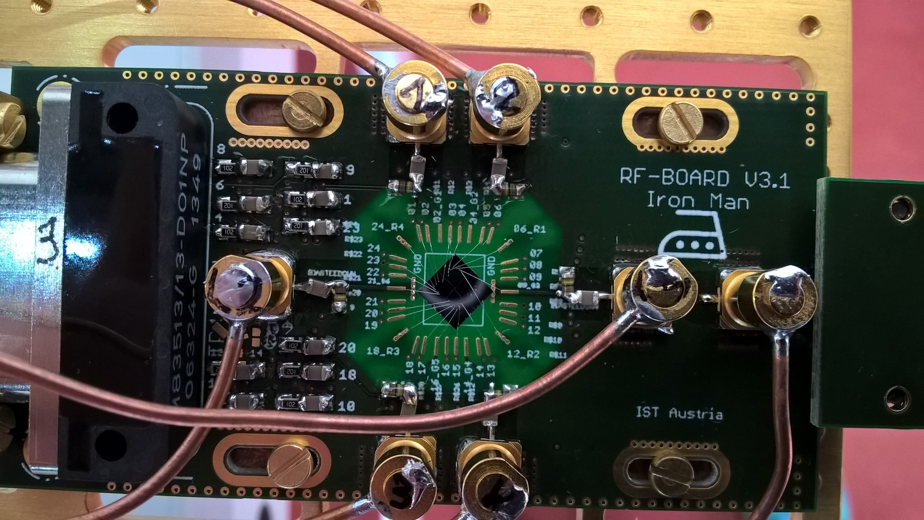

Fig. x1. PCB holder (green) with mounted nanowire based sample (middle, grey) fabricated in our group by Lada Vukušić. Altogether mounted on golden plated copper fork on the dilution fridge insert. Copper wires are coaxial cables providing high frequency connection for spin manipulation and readout. Nanometer gates and ohmic contacts on the sample are connected by wedge wire bonding.

Electrical connection with the sample is achieved through thermally low conductive looms for DC signals and coaxial cables for RF and microwave signals. *(put the picture of the probe)* All cables finish in PCB connector and further electrical contact with the sample is achieved by wedge wire bonding.

On room temperature side there are several instruments for sending and receiving the signals from the sample. Firstly, DQD and TQD needs to be tune in correct electrostatic configuration what is achieved through the low-noise, optically isolated, voltage DC sources.

Sequences of high-speed pulses (ranging from hundreds of nanoseconds to several milliseconds) coordinated together with bursts of microwave signals (several GHz up to several tens of GHz) are sent via coaxial cables to manipulate DQD and TQD charge and spin state thus **providing spin qubit manipulations**.

Pulses are generated by arbitrary waveform generator (Tektronix AWG5014C) and microwave signals by microwave signal source (Rohde & Schwarz SMF100A).

**Qubit state is read-out** by probing radio-frequency (RF) signal reflected from resonant circuit consisted of discrete inductor and capacitor and gate capacitance between DQD and TQD top gates and confined charge area in those. Probing is done by high frequency lock-in measurement technique using Zurich Instruments UHFLI lock-in amplifier.

### Hypoteses:

*(Don’t know what to put here and what in research metodology)*

Main hypotheses is that our gate reflectometry is sensitive enough to achieve fast quantum state readout. Read out parameter (one which needs to be boosted) by gate reflectometry is resonance frequency shift ∆f due to hole tunneling form one to another dot in DQD or TQD system: . Resonant frequency, , of resonance circuit depend on externally added lumped inductance L which is externally added, and parasitic capacitance Cp. Because L is easily tunable and Cp can be reduced to some level by engineering, main hypotheses is that quantum capacitance due to a hole tunneling, CQ is big. It is given by our sample and we expect it to be relatively high because of the following reasons.

*(This need to be changed according to Csigma)*

CQ depends on capacitive coupling of reflectometry readout gate to QDs in a qubit Cg, and parasitic capacitances Cp, according to:

Previous expression suggest that pathway for boosting sensitivity of gate reflectometry is to have Cg high and Cp low.

Since in our types of structures gates are positioned on the top of the nanowire (d is small, l and w are relatively large) consisting QDs (Fig 1.) we expect high Cg ,according to:

Small parasitic capacitance we are going to achieve by engineering our sample holder (PCB). Isolating PCB sample area from the ground by removing ground planes and decoupling RF and DC ground by putting relatively large resistors in DC line around that area. On Fig.x.1. around the sample PCB is translucent indicating that there is no copper ground plane.



Figure 1. Nanowire based single quantum dot, predecessor of double quantum dot on Fig.x.

## Research methods

Here we are proposing integration of two qubit Loss and DiVincenzo’s criteria in our type of qubit. First is **qubit state (spin) readout**. Other one is **spin state manipulation**.

### Qubit state readout:

C:\Users\jkukucka\Desktop\IST\DOC Fellowship\DQD_reflectometry.tif

Figure 2. Gate reflectometry schematic on the DQD sample from Fig.x1. LC resonators are connected to three of the gates. Signal from different gates are distinguished by frequency multiplexing since resonant frequencies are different because of different inductor values.

**What is reflectometry?**

Reflectometry is readout technique based on change of wave reflection coefficient Γ. It comes from electromagnetic wave principle – if the wave is travelling in media with impedance Z0  (e.g. coax cable) and it encounters change of impedance (e.g. coax end) to Z, portion of the wave will be reflected back according to the expression: , where Ar is amplitude and ᵠ( Ar) phase of the reflected, and Ain amplitude and ᵠ(Ain) phase of incoming wave. Reflection coefficient phase is ᵠ(Γ).

Putting resonant circuit with incorporated device instead of coax cable end one can measure change in impedance (capacitance) of that device. If elements of a resonant circuit – inductance L and capacitance C are properly chosen, on the resonant frequency of that circuit, , wave reflection coefficient Γ is minimized and it’s phase has inflection point and highest slope, Fig 2. top right blue and red.

In case of resonant LC circuit consisted of just L and C with very small R, Z is almost purely imaginary consisting of inductive and capacitive reactance. Thus if capacitance of sensed device changes -> ᵠ(Γ) changes and so phase of reflected wave ᵠ( Ar). Thus, by measuring phase of reflected wave ᵠ( Ar) and comparing it with ᵠ(Ain) one can get information of the impedance (capacitance) of sensed device.

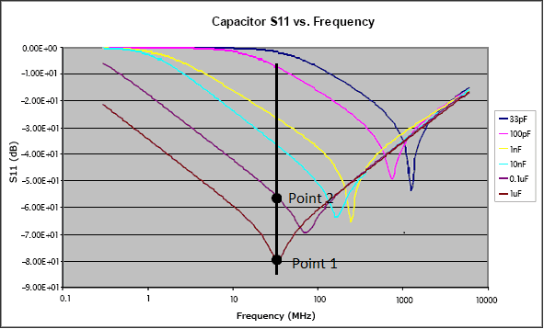

Fig 3. S11 parameter vs frequency for different capacitors *(put something from qucs instead of this one)*

**Our plan:**

RF wave (tens to hundreds of MHz) is generated and sent from UHFLI out port down the coax cable. Going through directional coupler and encountering three resonant circuit frequency multiplexed on different resonance frequencies by choosing different values for surface mount inductors L1, L2, L3. Each of this inductors will be wire bonded to finger like gates, as shown in Fig 2. Here is an example for nanowire, double quantum dot based qubit. Gates LP (left plunger) and RP (right plunger) are capacitively coupled to the left and right quantum dot respectively. When electron undergo tunneling between the dots there is an onset of quantum capacitance, changing overall capacitance seen by the resonant circuit, which changes resonance frequency (according to expression for f0) and consequently amplitude and phase of reflected wave which is then measured.

### Spin state manipulation:

*Write something about it*

# References:

J.I.Colless, Dispersive Readout of a Few-Electron Double Quantum Dot with Fast rf Gate-Sensors”

Some lecture: <http://www.physics.udel.edu/~msafrono/650/Lecture19.pdf>

About inductors: <http://info.ee.surrey.ac.uk/Workshop/advice/coils/air_coils.html>,

http://e-collection.library.ethz.ch/eserv/eth:5129/eth-5129-02.pdf

1. Platzman, P. M.; Dykman, M. I.; *Science* **1999,** *284,* 1967-1969
2. Jarryd J. Pla et al., *Nature* **2013** 496, 334–338
3. Jarryd J. Pla et al., *Nature* **2012** 489, 541–545
4. A. Morello et al., *Nature* **2010** 467, 687
5. Xiaobo Zhu1 el al., *Nature* **2011** 478, 221–224
6. H. Paik et al., *Phys. Rev. Lett.* **2011** 107, 240501
7. David P. DiVincenzo, [*arXiv:quant-ph/0002077v3*](http://arxiv.org/abs/quant-ph/0002077v3)
8. [F. K. Malinowski](https://arxiv.org/find/cond-mat/1/au:+Malinowski_F/0/1/0/all/0/1); [F. Martins](https://arxiv.org/find/cond-mat/1/au:+Martins_F/0/1/0/all/0/1); [P. D. Nissen](https://arxiv.org/find/cond-mat/1/au:+Nissen_P/0/1/0/all/0/1); [E. Barnes](https://arxiv.org/find/cond-mat/1/au:+Barnes_E/0/1/0/all/0/1); [Ł. Cywiński](https://arxiv.org/find/cond-mat/1/au:+Cywinski_L/0/1/0/all/0/1); [M. S. Rudner](https://arxiv.org/find/cond-mat/1/au:+Rudner_M/0/1/0/all/0/1); [S. Fallahi](https://arxiv.org/find/cond-mat/1/au:+Fallahi_S/0/1/0/all/0/1); [G. C. Gardner](https://arxiv.org/find/cond-mat/1/au:+Gardner_G/0/1/0/all/0/1); [M. J. Manfra](https://arxiv.org/find/cond-mat/1/au:+Manfra_M/0/1/0/all/0/1); [C. M. Marcus](https://arxiv.org/find/cond-mat/1/au:+Marcus_C/0/1/0/all/0/1); [F. Kuemmeth](https://arxiv.org/find/cond-mat/1/au:+Kuemmeth_F/0/1/0/all/0/1), [*arXiv:1601.06677*](https://arxiv.org/abs/1601.06677)
9. J. R. Petta et al., [*Science* **2005**309, 2180](http://pettagroup.princeton.edu/publications/2005/Science_309_2180_2005.pdf)
10. H. Watzinger et al., *[arXiv:1607.02977](https://arxiv.org/abs/1607.02977)*
11. R. Maurand et al., [*arXiv:1605.07599*](https://arxiv.org/abs/1605.07599)
12. Gonzalez-Zalba, M. F. et al., *Nat. Comm.*  2015 6, 6084
13. N. Ares et al., *Phys. Rev. Applied* 2016 5,034011
14. J. I. Colless et al., *Phys. Rev. Lett.* 2013 110, 046805
15. Juha T. Muhonen et al., *Nature Nanotechnology* 2014 9, 986–991
16. C. Fasth et al., *Nanoletters* 2005 5, 1487-1490
17. [M. Veldhorst](http://www.nature.com/nature/journal/v526/n7573/abs/nature15263.html#auth-1)., *Nature 2015* 52,410–414
18. [E. Kawakami](http://www.nature.com/nnano/journal/v9/n9/abs/nnano.2014.153.html#auth-1) et al., *Nat. Nanotechnology* 2014 9, 666–670
19. [D. J. Reilly](http://scitation.aip.org/content/contributor/AU0359152;jsessionid=0v5VY-bGXJiQk8fx_SoWO4Dw.x-aip-live-02) et al., *Appl. Phys. Lett.* 2007 **91**, 162101

G. Katsaros, Marie Curie proposal